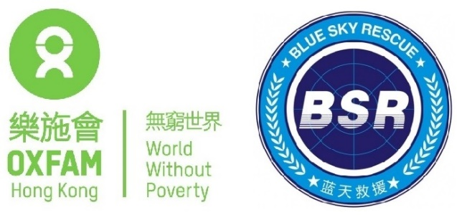
Sphere Training For Blue Sky Rescue
Yunyan District, Guiyang City, Guizhou Province, China
From April 7th to Aprile 12nd , 2023
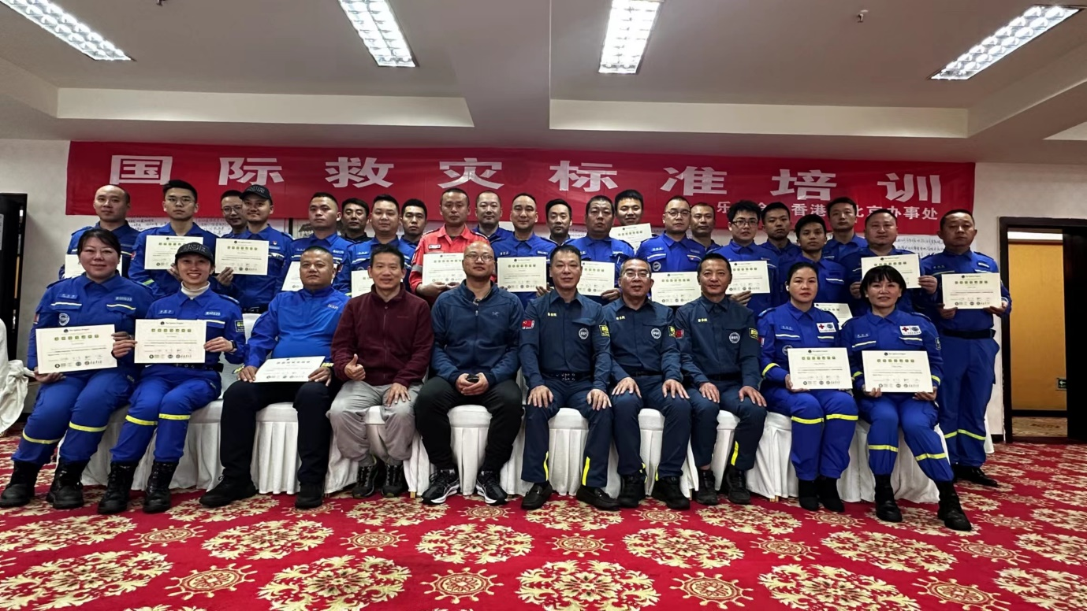
Background:
To improve the quality of humanitarian responses and to be accountable for the actions and, ensure that there are unified standards among all teams in future rescue activities and make it easier to promote communication and cooperation between brother rescue teams in different regions, Guizhou Blue Sky Rescue Team plans to conduct a five-day training course on the International Disaster Relief Standards in Guiyang from April 8 to April 12, 2023.
This Training will focus on the four core technologies of humanitarian relief and the Global Plan, how to use the standards, and cross-cutting themes. Through the training, institutions concerned with disaster relief gradually mastered the working principles and methods of some rescue projects, as well as the planning and management of projects. Through training, we promote the participation of actors in learning, and in addition to improving their own capabilities, they also establish a learning platform to exchange and share the knowledge they have learned with other partners, learn and grow together, and reflect on and summarize past disaster relief work together.
The event is sponsored by the Amity Foundation and Oxfam Hong Kong.
HOST
The Workshop was hosted by Oxfam Hong Kong & the Amity Foundation and the local partner organization Guizhou Blue Sky Rescue Team.
ABOUT OXFAM HONG KONG
Oxfam Hong Kong (OHK) was established in 1976. OHK envisages a world free of poverty and the injustices that stem from it. Around the globe, OHK works to find practical and innovative ways with people from poor communities, so they can lift themselves out of poverty and thrive. The working approaches include implementing long-term development programs in vulnerable communities, saving lives and rebuilding livelihoods when disaster/crisis strikes, and campaigning so that the voices of the poor influence the local and global decisions that affect them.
In China, in addition to implementing humanitarian responses, OHK prioritizes introducing and contextualizing universally recognized standards, such as the Sphere standards, with our partnership with local authorities, NGOs, and other relevant actors. In the past two decades, OHK has played a leadership role in communication, dissemination and localization of international humanitarian standards and best practices in China, especially on WASH and CASH Programming. Oxfam Hong Kong translated the Sphere Handbook 2018 into Simplified Chinese.
ABOUT THE AMITY FOUNDATION
The Amity Foundation, an independent Chinese social organization, founded in 1985 on the initiative of Chinese Christians led by Bishop K.H. Ting and joined by people from all walks of society, works to promote education, public health, social welfare, community development, environmental protection, disaster relief and other philanthropic undertakings in China and other parts of the world. Amity projects have benefited more than ten million people at home and abroad.
ABOUT GUIZHOU BLUESKY RESCUE TEAM
Guizhou Blue Sky Rescue Team was established in 2008 Wenchuan earthquake period, in 2012 officially registered in Guizhou Provincial Civil Affairs Department. After more than 10 years of development, Guizhou Blue Sky Rescue Team has developed from a civilian rescue team composed of professional volunteers into an integrated humanitarian agency, covering emergency rescue, humanitarian assistance, emergency response capacity enhancement, post-disaster order restoration and disaster reduction and prevention and other fields.
ABOUT GUIZHOU BLUESKY RESCUE TEAM
Guizhou Blue Sky Rescue Team was established in 2008 Wenchuan earthquake period, in 2012 officially registered in Guizhou Provincial Civil Affairs Department. After more than 10 years of development, Guizhou Blue Sky Rescue Team has developed from a civilian rescue team composed of professional volunteers into an integrated humanitarian agency, covering emergency rescue, humanitarian assistance, emergency response capacity enhancement, post-disaster order restoration and disaster reduction and prevention and other fields.
PARTICIPATION:
Lead Facilitator: FU，Yu ；Cui, Yazhou ； Lei，Guangqing
Cofacilitator： Wang，Yi
Trainee Trainer： Wang, Yi
Evaluator: Wang, Yi
Guest Speaker: He， Qingrong
Trainee：30 rescuers of the Blue Sky rescue team involved in earthquake relief in Turkey
Goals/learning objectives:
- Proficiency in Sphere 2018 Chinese.
- Apply the Sphere 2018 Chinese to design humanitarian relief projects.
AGENDA:
Aprile 7th Check-in
Time | content | Objectives
19:30 | Watch the movie " The Rwanda Hotel " | - The film introduces historical scenes to help participants understand the situation of people in the midst of disasters and conflicts
21:40 | Introduction to Sphere
Aprile 8th
Time | content | Objectives
8:30–8:45 | The organizer gave a welcome speech, Wang Yi
8:45–10:15 | STP 1： Welcome and Introduction  Wang Yi | - Follow the basic norms and housekeeping guidelines for this event  - Exchange information with your  co-participants and facilitators  - Explain what Sphere is in terms of “Learn, Act, and Connect”  - Prepare well for each session
10:15–10:30 | Coffee break
10：30-12：00 | Stp 2： What is Sphere?  Lei，Guanqing | - Concisely explain Sphere’s core philosophy  - Navigate the Sphere Handbook structure and components as an informed user  - Advocate for using all of the Sphere Handbook in guiding humanitarian action  - Use the Code of Conduct to guide humanitarian response:
12：00-14:00 | Lunch and lunch break
14：00-14:10 | Warm-up activities
14：10-15：40 | STP 4： Humanitarian Charter  STP 5： Protection Principles  Cui，Yazhou | - Explain how the 12 elements of the Humanitarian Charter affect humanitarian response programmes  - Give examples of how these four protection principles have been put into practice throughout the humanitarian programme cycle  - Explain the need for professional standards for conservation work
15:40–16:00 | Coffee break
16:00– 17:30 | STP 15： Sphere and PSEA  Fu，Yu | - Explain the terminology  - Explain how sexual harassment, exploitation and assault are interrelated and what different protection and response strategies are needed  - Review institutional protection policies
17:30-17:40 | Daily assessments
Evening | Watch the movie: "The Whistleblower" understands the context of preventing sexual misconduct; The group discussed the afterthoughts, reviewed the existing problems of the institutions in the group on protection principles, prevention of sexual misconduct and abuse of power (group 6), and proposed plans and strategies for establishing or improving the institutional safeguard policy.  FU, Yu

Aprile 9th
Time | content | Objectives
8:00–8:15 | Review and review, assessment feedback
8:15-8;45 | The group reported the results of last night's discussion, the sharing form is not limited, all 6 groups share and cross-comment。
8:45–10:15 | STP 6：CHS  Fu，Yu | - Locate and apply the nine commitments of the Core Humanitarian Standard (CHS) to your own work  - Identify challenges to humanitarians in meeting the commitments of the CHS and propose ways to overcome them.
10:15–10:30 | Coffee break
10：30-12：00 | STP 6：CHS  Fu，Yu | - Locate and apply the nine commitments of the Core Humanitarian Standard (CHS) to your own work  - Identify challenges to humanitarians in meeting the commitments of the CHS and propose ways to overcome them.
12：00-14：00 | Lunch and lunch break
14：00-14：10 | Warm-up activities
14：10-15：40 | STP 12：Sphere and the Programme Cycle  Cui，Yazhou | - Describe the five phases of the programme cycle  Apply Sphere guidance to support humanitarian response at each phase of the cycle
15:40– 16:00 | Coffee break
16:00– 17:30 | STP 17： Sphere, Cash and Markets.  Lei,Guangqing | - Concisely explain the philosophy of decision-making for cash-based assistance (CBA) vs. in-kind assistance  - Navigate the assessment process required to successfully design a CBA programme
17:30-17:40 | Daily assessments
Evening | Preview WASH, break out group discussions and practice role-play in WASH cases  Lei, Guangqing

Aprile 10th
Time | content |  | Objectives
8:00–8:15 | Review and review, assessment feedback
8:15–9:45 | STP 7：WASH  Lei, Guangqing |  | - Explain the primary objective and three essential concepts behind WASH programming  - Identify the main transmission pathways of infectious pathogens and barriers to break the chains of transmission  - Use some of the technical numerical indicators with enhanced confidence and understanding  - Relate the quantitative technical aspects of Sphere to its foundational rights-based aspects
9:45–10:00 | Coffee break
10：00-12：00 | STP 7：WASH  Lei, Guangqing |  | - Through role-play performances, participants experienced the different WASH problems faced by different groups of people in disaster situations
12：00-14：00 | Lunch and lunch break
14：00-14：10 | Warm-up activities
14：10-15：40 | STP 8 Food Security and Nutrition  Cui，Yazhou |  | - Explain the links between the food and nutrition sector and other response sectors  - Visualise and describe one of the most commonly cited indicators – the minimum daily food energy requirement  - Use common food and nutrition terms and acronyms correctly when reading assessment reports or contributing to multi-sectoral discussions  - Choose between food response strategies based on contextual factors
15:40– 16:00 | Coffee break
16:00– 17:30 | STP 8 Food Security and Nutrition  Cui，Yazhou |  | - Learn about food baskets
17:30-17:40 | Daily assessments
Evening | Group preparation of shelter and resettlement case discussion
Aprile 11st
Time |  | content | Objectives
8:00–8:15 |  | Review and review, assessment feedback
8:15–9:45 |  | STP 9 Shelter and Settlement  Fu，Yu | - Apply Sphere guidance to improve shelter assistance for immediate emergency programming and for the longer term  - Visualise some commonly cited Sphere shelter indicators and describe them in “human terms” rather than simply as numbers  - Identify strengths and challenges of different shelter programming options in different contexts
9:45–10:00 |  | Coffee break
10：00-12：00 |  | STP 9 Shelter and Settlement  Fu，Yu | Each group reports on the Settlement plan
12：00-14：00 |  | Lunch and lunch break
14：00-14：10 |  | Warm-up activities
14：10-15：40 |  | STP 18：HSP  Lei, Guangqing | - Describe the general guidance provided, structure, and application of the seven partner standards
15:40– 16:00 |  | Coffee break
16:00– 17:30 |  | STP 20：Evaluation and Wrap-Up  Wang，Yi | Review, reflect and evaluate this workshop activity and what you have learned  - Develop an action plan
Aprile 12nd
Time | Facilitator |  | content
8:30–10:15 | He Qingrong |  | - International Rescue Response Process and Precautions
10:15–10:30 | Coffee break
10：30-12：00 | He Qingrong |  | - 《International rescue response procedures and precautions二》
12：00-14:00 | Lunch and lunch break
14：00-14：45 | Wang，Yi |  | - International Humanitarian Law
14:45– 15:00 | Coffee break
15:00– 16:00 | Wang，Yi |  | - International Rescue Procedures and Methods
16:00-17:00 | Graduation ceremony
This training mainly uses scenario learning as the main method, except for the WASH session, which uses the 2020 Henan flood as the study case, other chapters use the Turkish earthquake as study case. On the evening before the training start , watching the movie "Hotel Rwanda" transported the participants into the historical background of Sphere, so that all participants could deeply appreciate the situation of disaster and conflict; In the "What is the Global Plan" chapter on the first day, the mentors asked the participants to use the Turkish earthquake as an example to analyze and discuss their performance in the rescue using the 1.0 criteria of the Code of Conduct; Watch the movie: "The Whistleblower" understands the context of preventing sexual misconduct; The second night, participants rehearsed role-plays to understand the gaps of different groups of people in WASH; On the third day, the food security and nutrition chapter, as well as the shelter and shelter chapter, required participants to discuss and design food baskets and shelter accommodation for 4,000 people in the case of the earthquake in Turkey.
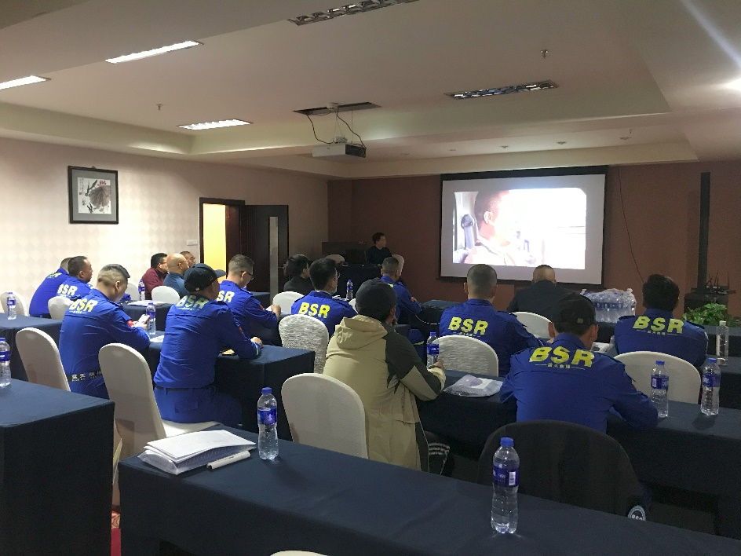
Watch the movie " The Rwanda Hotel "
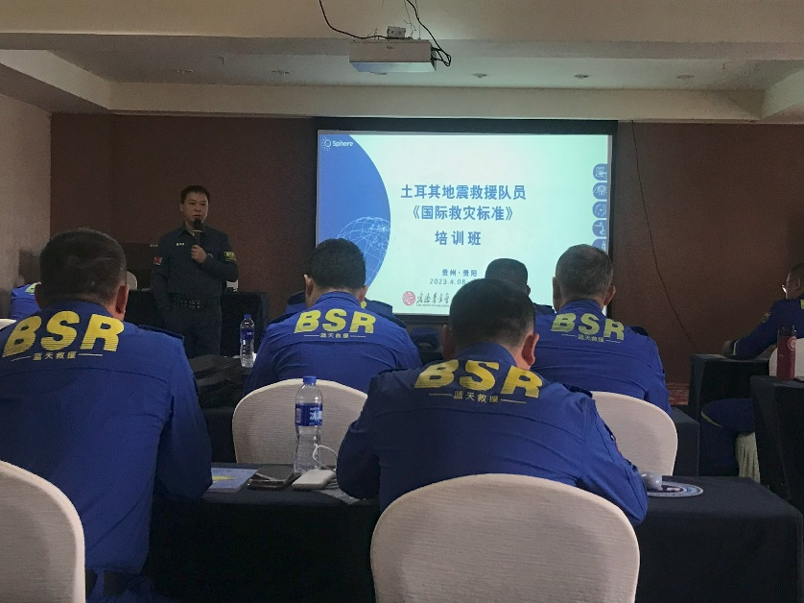
Welcome and Introduction, WANG,YI
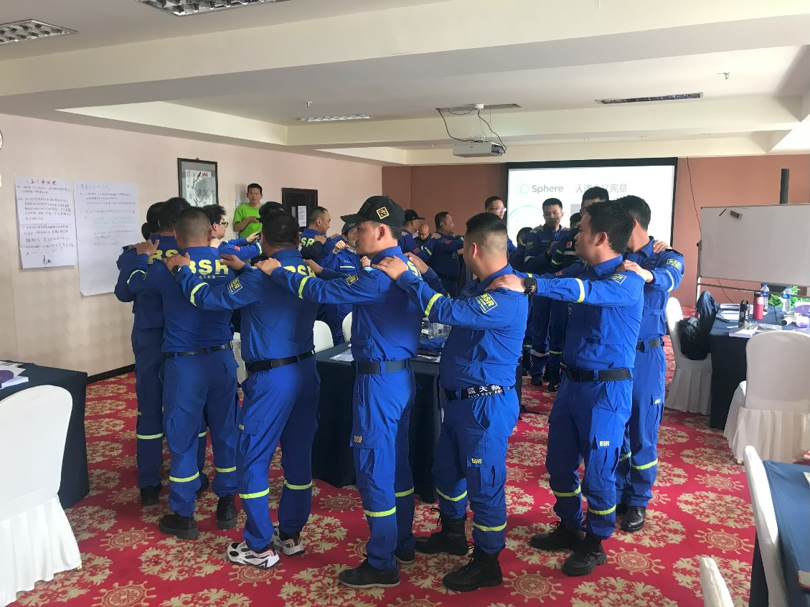
Games
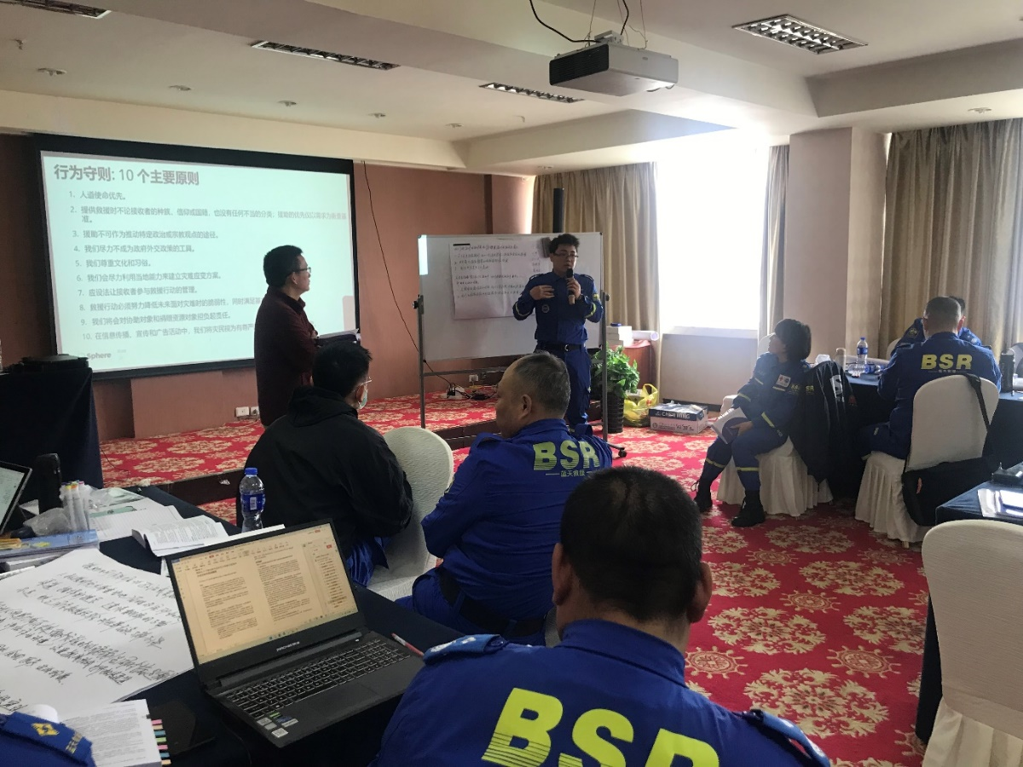
Subgroups report on the performance of the Code of Conduct in Turkey earthquake relief
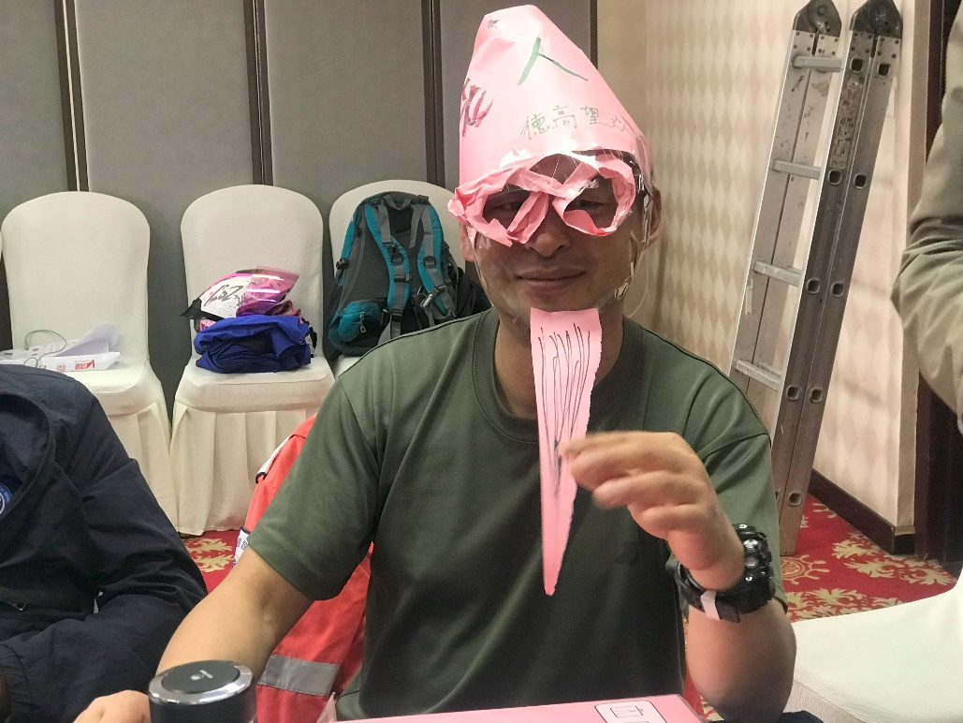
WASH，Role playing
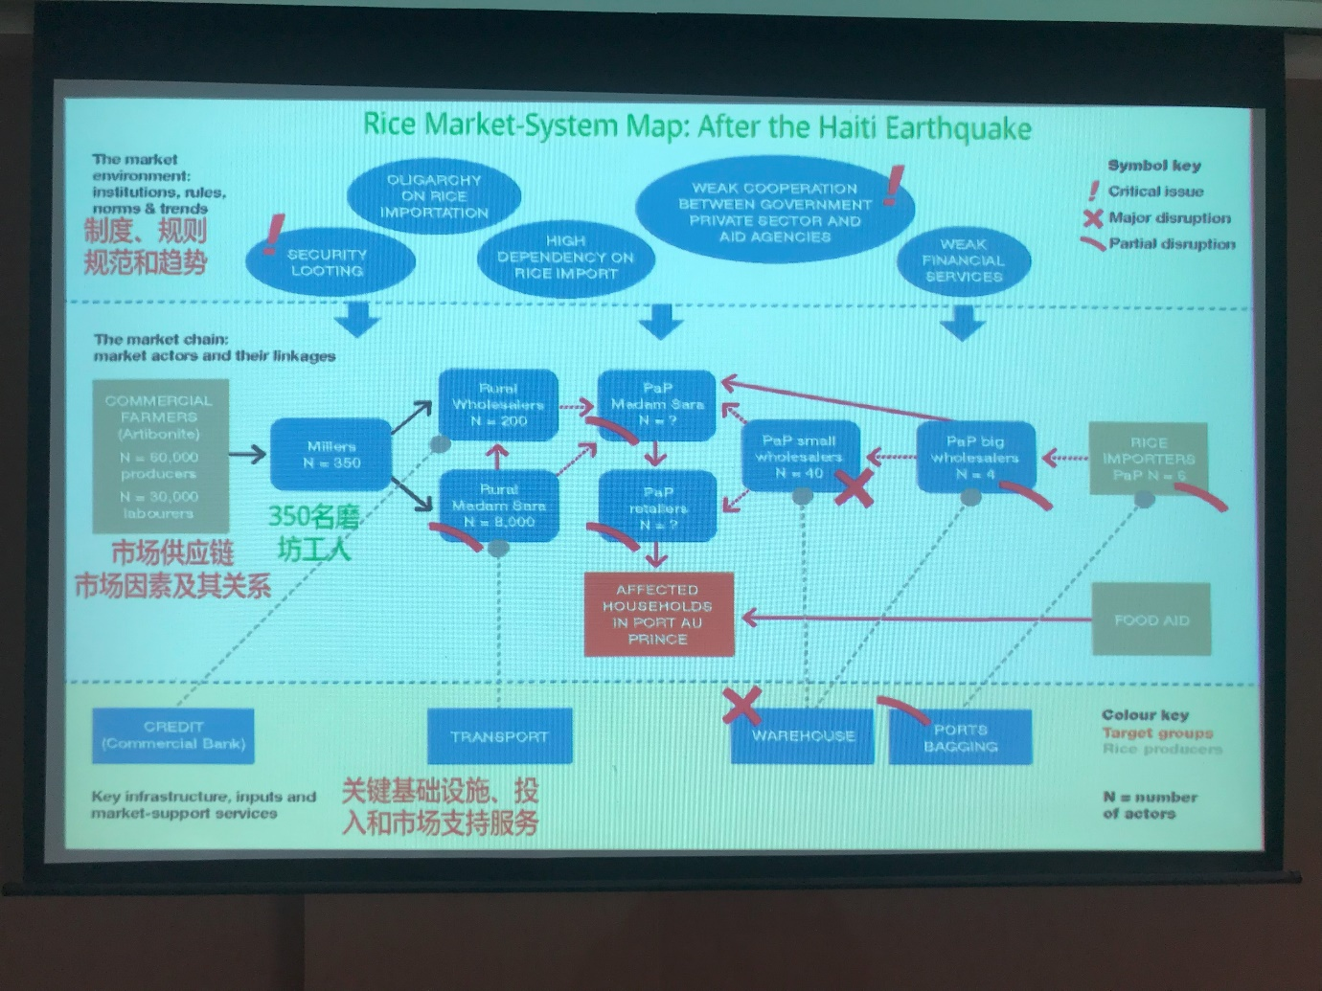
Sphere, Cash and Markets. Lei,Guangqing
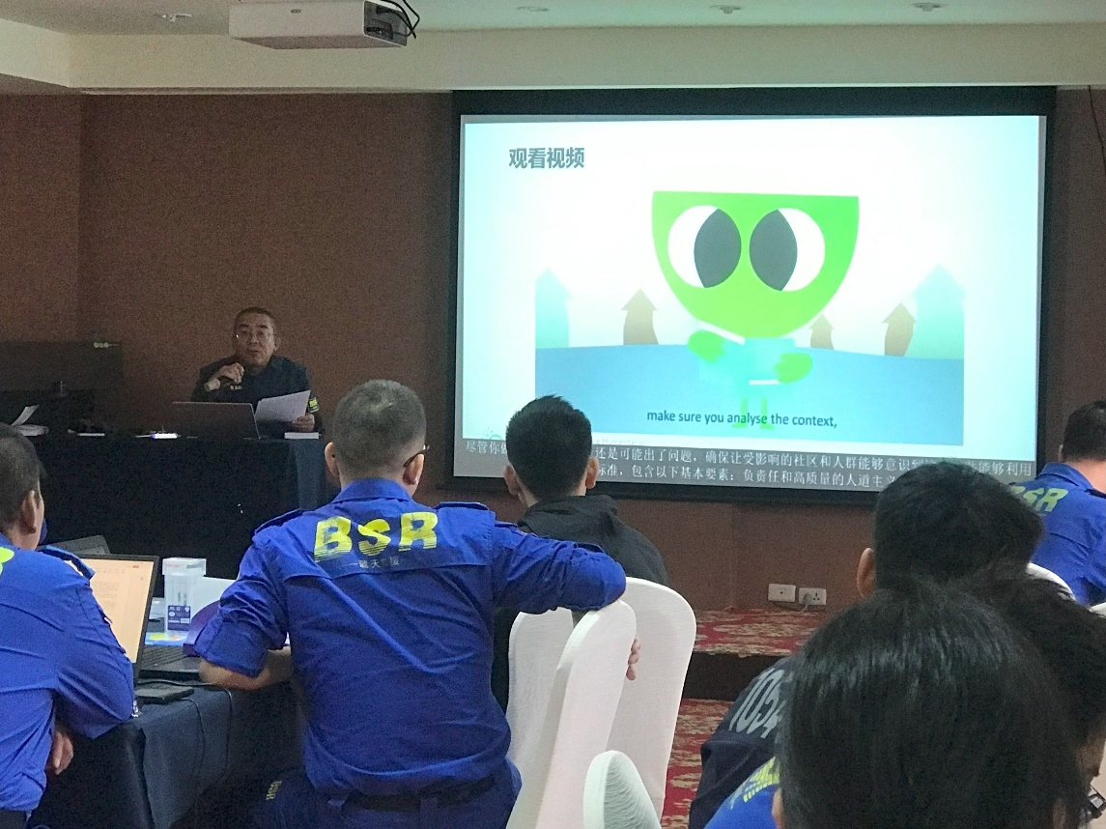
Sphere and PSEA , FU, Yu
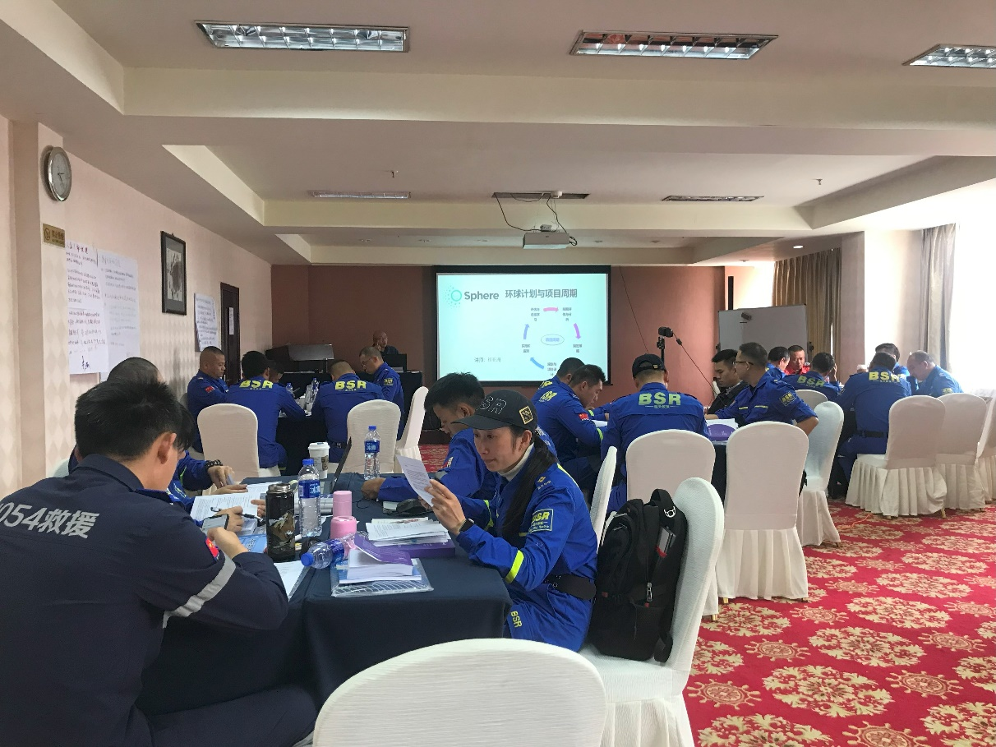
Sphere and the Programme Cycle, Cui，Yazhou
Map of the resettlement
SUMMARISED PARTICIPANT SURVEY RESULTS
Comparison of pre-test and post-test:
The training conducted a pre-test and a post-test online, with an average score of about 70 points (out of 150) and an average post-test score of more than 130 points.
Final evaluation was conducted at the course closure:

BEST PRACTICES
- The case discussion is in line with the earthquake rescue practice in Turkey.
- Group learning is efficient;
- Participatory learning stimulates students' interest in learning
CONCLUSIONS: This is an advanced training course of Sphere, 30 participants from 21 rescue teams in China, about half of the participants have a certain degree of understanding of Sphere.The training focuses on training participants to design humanitarian relief projects from the perspective of project management, and the training takes the "Turkish earthquake relief" they just experienced as a case study for in-depth discussion, learning and practice. 100% of the participants were satisfied with the training and 87% rated it as excellent.

